**Software Testing Projects FTS**

* Learning:
* Manual Testing
* SQL
* Agile Metholodagy
* JIRA
* Programing Language
* Automation Test
* Frameworks

**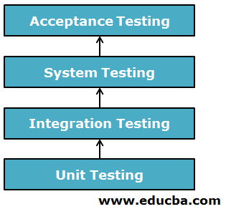**

* **Important key test must do all the Software Eng.:**
* **Unit Test.**
* **Integration Test.**
* **System Test.**
* **Acceptance Test.**
* **Unit Test:**

Unit testing is **a software development process in which the smallest testable parts of an application, called units, are individually and independently scrutinized for proper operation**. This testing methodology is done during the development process by the software developers and sometimes QA staff.

A unit is a single testable part of a software system and tested during the development phase of the application software. The purpose of unit testing is **to test the correctness of isolated code**

* **Advantages of Unit Testing:**
* The process becomes agile. This is the main benefit of unit testing
* Quality of Code. Unit testing significantly improves code quality. ..
* Find Software Bugs Easily. ...
* Facilitates Change. ...
* Provides Documentation. ...
* Debugging Process. ...
* Design. ...
* Reduce Costs.
* What are the unit testing tools?

[[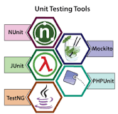](https://www.google.com/search?cs=0&sxsrf=ALiCzsbuP5E4jED24kYkQJCsXTf7fwcEmA:1654857426603&q=What+are+the+unit+testing+tools?&tbm=isch&source=iu&ictx=1&vet=1&fir=mt9Io8SfxI_TbM%252CC7EXA7QLf6XWHM%252C_&usg=AI4_-kSYROmXWY9OddeAzZW8vbfBjjND2w&sa=X&ved=2ahUKEwi6sLqo2KL4AhU7TGwGHUepCc8Q9QF6BAgLEAE#imgrc=mt9Io8SfxI_TbM) 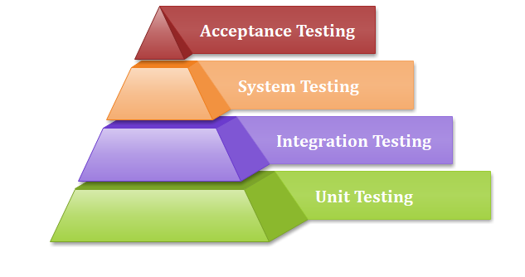](https://www.google.com/search?cs=0&sxsrf=ALiCzsbuP5E4jED24kYkQJCsXTf7fwcEmA:1654857426603&q=What+are+the+unit+testing+tools?&tbm=isch&source=iu&ictx=1&vet=1&fir=mt9Io8SfxI_TbM%252CC7EXA7QLf6XWHM%252C_&usg=AI4_-kSYROmXWY9OddeAzZW8vbfBjjND2w&sa=X&ved=2ahUKEwi6sLqo2KL4AhU7TGwGHUepCc8Q9QF6BAgLEAE" \l "imgrc=mt9Io8SfxI_TbM)

**Unit testing tools**

* NUnit.
* JUnit.
* TestNG.
* Mockito.
* PHPUnit.
* [**https://www.youtube.com/watch?v=jFQfuIEd8sU**](https://www.youtube.com/watch?v=jFQfuIEd8sU)
* <https://www.youtube.com/watch?v=SOhM7UP-C0I>
* Unit Testing Techniques:

Unit testing uses all white box testing techniques as it uses the code of software application:   
 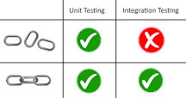

* Data flow Testing
* Control Flow Testing
* Branch Coverage Testing
* Statement Coverage Testing
* Decision Coverage Testing

## Example of Unit testing

Let us see one sample example for a better understanding of the concept of unit testing:

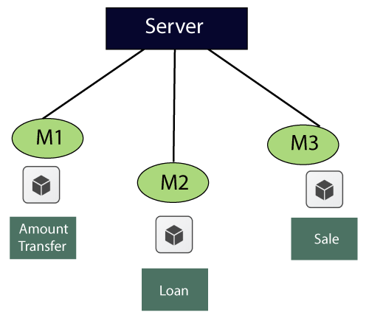

* **Integration Test:**

Integration testing -- also known as integration and testing (I &T) -- is **a type of software testing in which the different units, modules or components of a software application are tested as a combined entity**. However, these modules may be coded by different programmer

**Integration testing is the phase in software testing in which individual software modules are combined and tested as a group. Integration testing is conducted to evaluate the compliance of a system or component with specified functional requirements. It occurs after unit testing and before system testing.**

The purpose of the integration testing is **to expose faults in the interaction between integrated units**. Once all the modules have been unit tested, integration testing is performed.

**Some different types of integration testing are**

* **Big-bang, mixed (sandwich),**
* **Risky-hardest,**
* **Top-down,**
* **Bottom-up**.

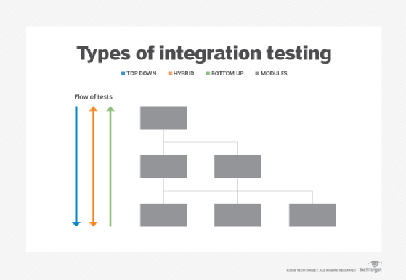

**Other Integration Patterns are:**

* Collaboration integration,
* Backbone integration,
* Layer integration,
* Client-server integration,
* Distributed services integration
* High-frequency integration.

<https://www.youtube.com/watch?v=8UfQ8quw0Eg>

<https://www.youtube.com/watch?v=xZSYh4JxzTY>

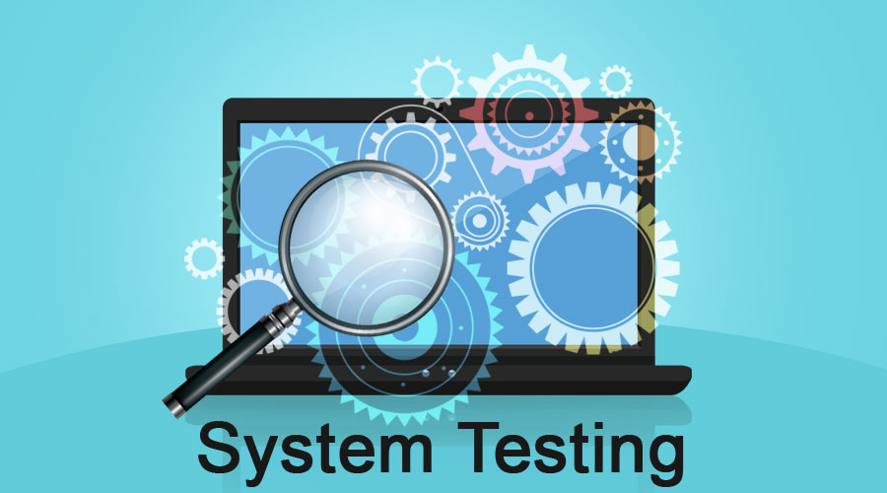

* **SYSTEM TEST:**